Lenten Program 2021
As we begin to prepare for Easter, we are happy to share with you 3 programs that are available to us as a community of faith where we can journey together as fellow pilgrims. Everyone is most welcome to join all or some of the programs. The invitation is that we journey together in love and joy towards Easter. The basis of the Lenten retreat is Ignatian Spirituality.
All the information can be found as outlined below.
Online Lenten retreat - Knowing Jesus:
Starts on 17 February 2021
You are invited to join our daily virtual Lenten retreat, “Knowing Jesus”. The daily readings, reflections, picture and music can be found here
This program is led by our friends of the ISC Glasgow.
If you wish to join a group that will meet weekly, kindly register early here to avoid any disappointment.

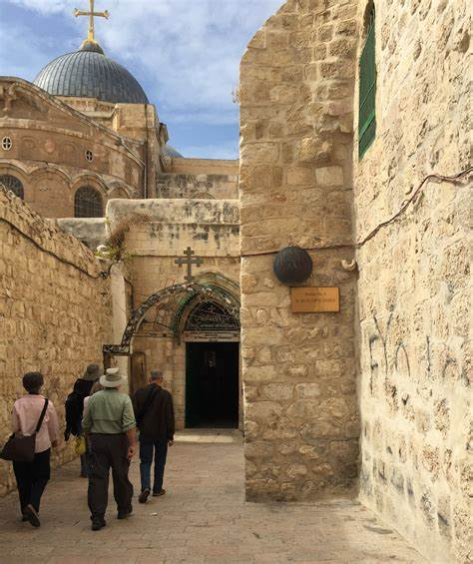
Online Stations of the Cross in the Holy Land:
Starts 19 February 2021
We heartily invite you to join us every Friday during Lent from 15.00-16.00 CET for the Stations of the Cross.
The Stations will be prayed with our fellow pilgrims in the Holy Land and we will walk with them virtually the via Dolorosa.
Details of this program can be found here.
To obtain the zoom details please register by clicking here

Online Holy Week series from and in the Holy Land:
Starts 28 March 2021
Let us start the Holy Week by walking together virtually down from the Mount of Olives, on Palm Sunday just as Jesus did more than 2000 years ago.
Join our tour guides and lecturers in the Holy Land for a week of prayer, reflection and virtual sightseeing.
When: 28 March (Sunday) to 3 April (Saturday)
Times: 14.00 -15.00 CET or 19.00-20.00 CET depending on day
Registration: ISC Geneva
More details : Overview of schedule and topics

This program is done in partnership between Tantur, ISC Geneva, ISC Glasqow and John XXIII Parish

